IOT SMART BIN

DATE : 14/03/22 -- 18/03/22

***Servo Motor:***

<https://create.arduino.cc/projecthub/akshayjoseph666/servo-motor-interface-with-arduino-uno-9693ad>

Ultra sonic sensor:

<https://create.arduino.cc/projecthub/user1891676/interfacing-ultrasonic-sensor-with-arduino-99ba38>

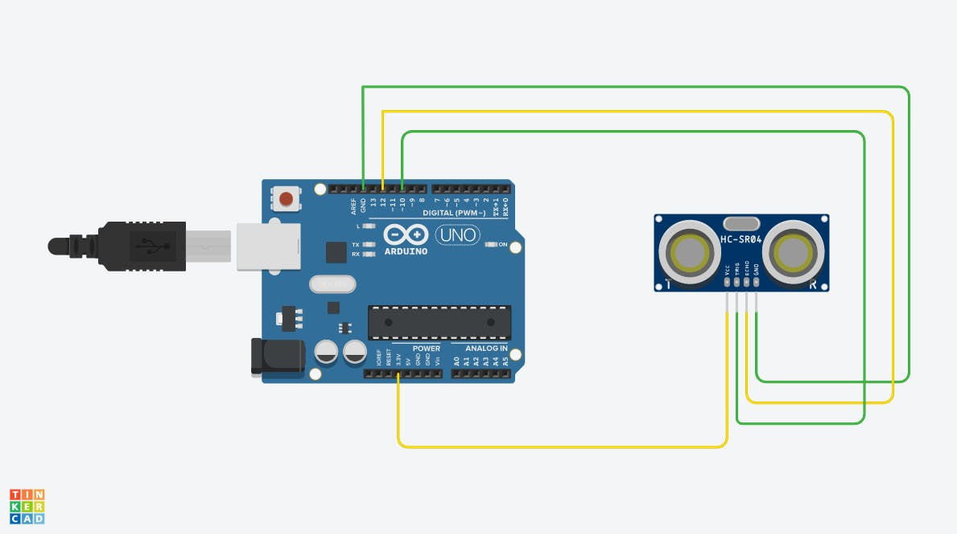

## PART I

***LCD with Ultrasonic sensor***:

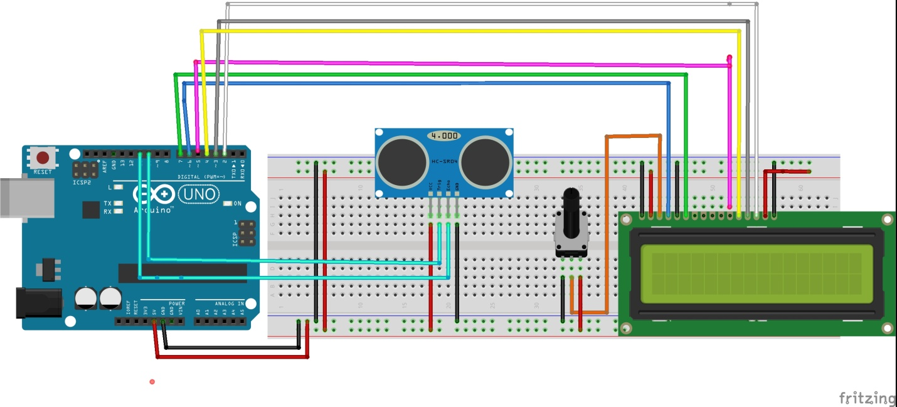

<https://create.arduino.cc/projecthub/Techinc1510/hc-sro4-distance-measurer-with-lcd-1602-f94579>

***Program:***

#include <LiquidCrystal.h>

LiquidCrystal lcd(6 , 7, 5, 4, 3, 2);

const int trigPin = 11;

const int echoPin = 10;

long duration;

int distanceCm, distanceInch, fill;

void setup() {

lcd.begin(16,2); // Initializes the interface to the LCD screen, and specifies the dimensions (width and height) of the display

pinMode(trigPin, OUTPUT);

pinMode(echoPin, INPUT);

Serial.begin(9600);

}

void loop() {

digitalWrite(trigPin, LOW);

delayMicroseconds(2);

digitalWrite(trigPin, HIGH);

delayMicroseconds(10);

digitalWrite(trigPin, LOW);

duration = pulseIn(echoPin, HIGH);

distanceCm= duration*0.034/2;

distanceInch = duration*0.0133/2;

fill=1;

fill=(distanceCm)*100;

fill/=30;

fill-=100;

if(fill<0){

fill*=-1;

}

Serial.print("Distance : ");

Serial.print(distanceCm);

Serial.print(" cm . Level : ");

Serial.println(fill);

delay(2000);

lcd.setCursor(0,0); // Sets the location at which subsequent text written to the LCD will be displayed

lcd.print("SMART DUSTBIN");

delay(10);

lcd.setCursor(0,1);

lcd.print("LEVEL: ");

lcd.print(fill);

lcd.print("%");

delay(10);

}

## PART II

***US sensor with Servo Motor:***

<https://create.arduino.cc/projecthub/lakshyajhalani56/smart-dustbin-using-arduino-ultrasonic-sensor-servo-motor-1b655e?ref=user&ref_id=1620279&offset=9>

***PROGRAM :***

#include <Servo.h>

Servo servoMain; // Define our Servo

int trigPin = 10;

int echopin = 12;

int distance,pos;

float duration;

float cm;

void setup()

{

servoMain.attach(3); // servo on digital pin 10

Serial.begin(9600); //set the baud rate of serial communication to 9600

pinMode(trigPin, OUTPUT);

pinMode(echopin, INPUT);

}

void loop(){

digitalWrite(trigPin,LOW); //generate square wave at trigger pin

delayMicroseconds(2);

digitalWrite(trigPin,HIGH);

delayMicroseconds(10);

digitalWrite(trigPin,LOW);

duration = pulseIn(echopin, HIGH);

distance=(duration*0.034/2)

Serial.print("Distance : ");

Serial.print(distance);

Serial.println(" cm . ");

delay(100);

if(distance<30)

{ for(pos=0;pos<=110;pos++){

servoMain.write(pos);

delay(15); }

delay(1000);

for(pos=110;pos>=0;pos--){

servoMain.write(pos);

delay(15); }

}

else{

servoMain.write(0);

delay(50);}}

